Beste Practice End To End Project

Ref: https://www.youtube.com/watch?v=iQ41WqhHglk

Architecture and Services
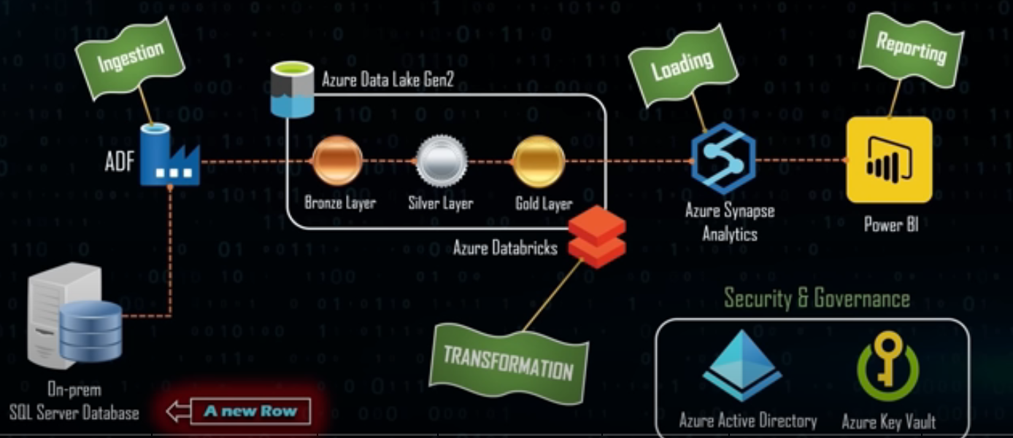

Ingestion On-Premise to ADL (using Data Factory)

- Look up activities (loading table names from the SQL DB)
- Azure Self hosted Runtime (Connecting On-premise and Cloud resources)
- Foreach Loop (copying tables 1 by 1 from SQL to ADL)
- Folder structure like Schema/tableName/TableName.parquet
- Create needed linked service in ADF (sql, ADL, KeyVault…)

Transform data using DATABRIKS

Set up
- Create a Cluster
- Create your notebooks in there
- On of the notebook (will be the mounting one)
  - To connect DataBriks to the dedicated folder in ADL (Bronzze, Silver, Gold)

First transformation
- Basic and data quality transformations (data type, column names , naming conventions)
- Markdown for description for each cell
- For each loop
- Creating delta tables on the Silver folder

2nd transformation
- Join tables to create fact and Dimension tables
- Store the result as Delta tables in the Gold folder

Run the Notebooks with ADF
Note : Once Mounted the ADL and Databriks do not needed anymore to be mounted and Linked services will be needed from ADF to Connect to DataBriks
- The orchestration of the Notebook run can start using ADF in the good order (
  - From Bronze to Siler and
  - from Silver to Gold
- Realtime monitoring is possible to see the steps in realtime in Dbriks Notebooks

Load data in Sysnapse (Serverless)
- Create views base on the Gold folder for all tables
- Use these view to coonect to Tabular or Power BI (Import mode and shared dataset)

